**Asiqul Hoque**

**Homework 10**

**Conversion Functions**

**1.** select last_name,to_char(birthdate,'fmMonth DD, YYYY')

from f_staffs;

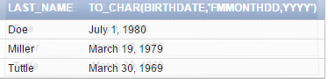

**2.** Select TO_DATE('January 3, 2004', 'Month dd, yyyy')

FROM dual;



**3.** SELECT ' The promotion began on the ' ||   
TO_CHAR(start_date, 'ddspth') || ' of ' ||   
TO_CHAR(start_date, 'Month YYYY')   
As "Formatted_Query"  
FROM f_promotional_menus  
where code = 110;



**4.** SELECT 'Today is the ' || to_char(sysdate,'Ddspth') || ' of '||   
to_char(sysdate,'Month') ||', '||   
to_char(sysdate,'Year') AS "Number4"  
from dual;



**5.** SELECT id,first_name,last_name,to_char(salary,'$999999.99') AS "Salary"  
from f_staffs;

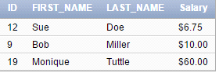

**6.** SELECT first_name,last_name,salary,to_char(salary+2000,'$999999.99') AS "New Salary"

from employees

where last_name = 'Abel';



**7.** select start_date,to_char(start_date,'D') AS "Week"

from f_promotional_menus

where code=110;



**8.**

select To_char('20-dec-04','Month ddth,YYYY')

from dual;

***Result: December 25th,2004***

select to_char('20-dec-04','MONTH ddTH,YYYY')

from dual;

***Result: DECEMBER 25TH,2004***

select to_char('20-dec-04','month ddth,YYYY')

from dual;

***Result: december 25th, 2004***

**9.**select to_char(low_range,'$99999999.99') AS "LOW RANGE",

to_char(high_range,'$9999999999.99') AS "HIGH RANGE"

from d_packages;

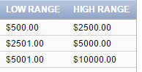

10. select TO_DATE('061904', 'fxMMDDYY')

from dual;



11. Implicit conversion means that the database engine will convert the data type automatically, a process invisible to the user. On the other hand, Explicit conversion means that you must specify how the data type should be converted.

Implicit example: Convert VARCHAR2 to Number data type.

Explicit example: Convert VARCHAR2 and CHAR data to NUMBER and DATE data types. AND vice versa, convert NUMBER and DATE data back to CHARACTER datatype.

12. In a business prespective, it is important to have datatype conversions as it provides accurate information all time such as when the need arises to display numbers as local currency, displaying time to the second, and in order keep track of what century a date refers to.